Assignment 10: Salesforce Mini Project

Project Overview
A complete Library Management System to manage books, members, and book issues/returns.

Steps
- Create 3 Custom Objects
- Add Fields to each Object
- Create LibraryController class
- Create Test class
- Run Execute Anonymous
- Check Debug Logs

Custom Objects
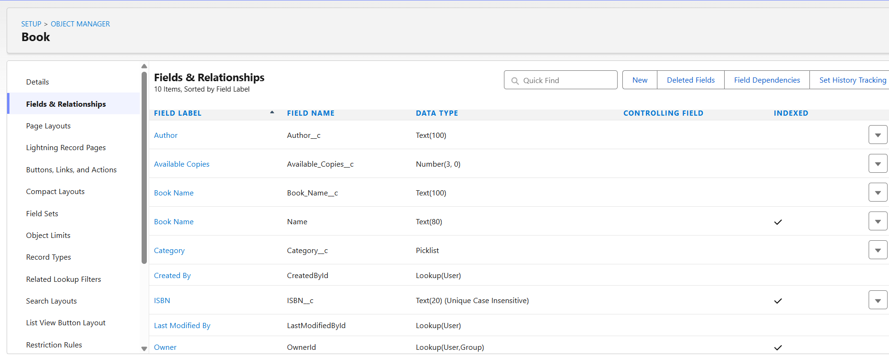
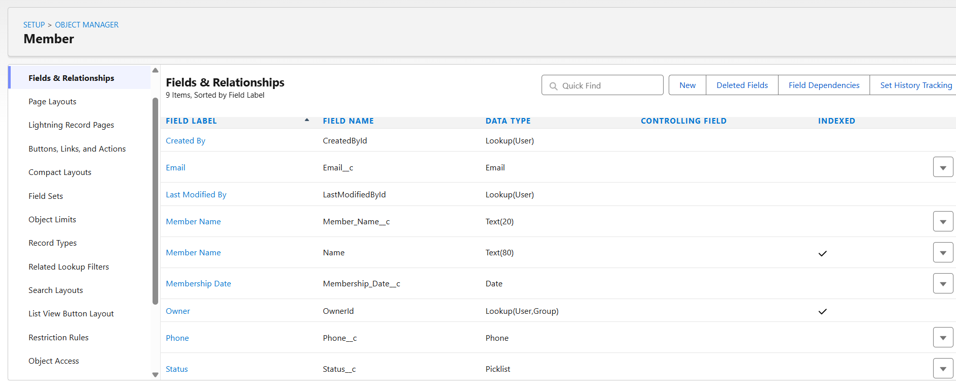
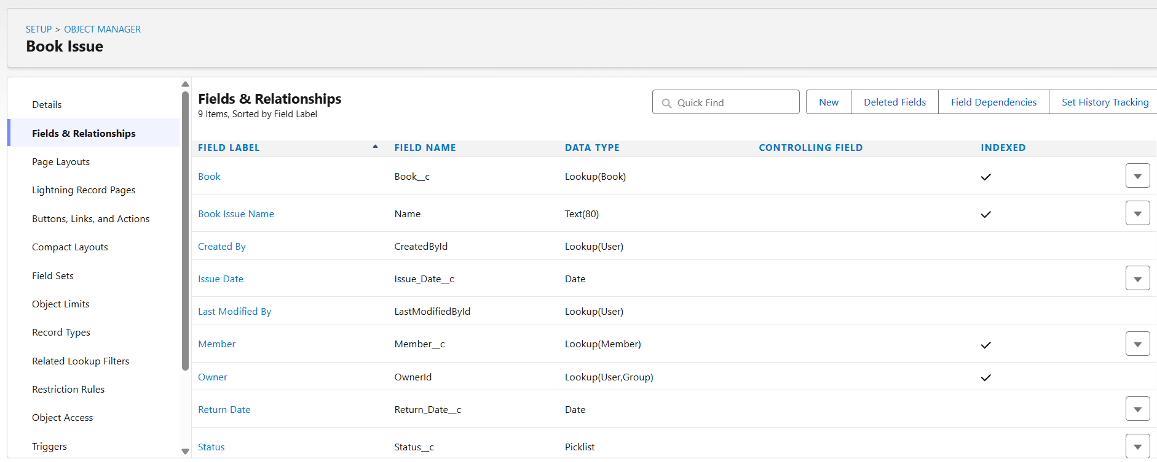

Apex Classes
1. LibraryController.apxc
public class LibraryController {

// Add new book to library
public static String addBook(String bookName, String author, String isbn,
String category, Integer totalCopies) {
try {
Book__c book = new Book__c();
book.Book_Name__c = bookName;
book.Author__c = author;
book.ISBN__c = isbn;
book.Category__c = category;
book.Total_Copies__c = totalCopies;
book.Available_Copies__c = totalCopies;

insert book;
return 'Book added successfully! ID: ' + book.Id;
} catch(Exception e) {
return 'Error: ' + e.getMessage();
}
}

// Register new member
public static String registerMember(String name, String email, String phone) {
try {
Member__c member = new Member__c();
member.Member_Name__c = name;
member.Email__c = email;
member.Phone__c = phone;
member.Membership_Date__c = Date.today();
member.Status__c = 'Active';

insert member;
return 'Member registered successfully! ID: ' + member.Id;
} catch(Exception e) {
return 'Error: ' + e.getMessage();
}
}

// Issue book to member
public static String issueBook(Id bookId, Id memberId) {
try {
// Check if book is available
Book__c book = [SELECT Available_Copies__c FROM Book__c WHERE Id = :bookId];

if(book.Available_Copies__c <= 0) {
return 'Book not available!';
}

// Create issue record
Book_Issue__c issue = new Book_Issue__c();
issue.Book__c = bookId;
issue.Member__c = memberId;
issue.Issue_Date__c = Date.today();
issue.Status__c = 'Issued';

insert issue;

// Decrease available copies
book.Available_Copies__c = book.Available_Copies__c - 1;
update book;

return 'Book issued successfully! Issue ID: ' + issue.Id;
} catch(Exception e) {
return 'Error: ' + e.getMessage();
}
}

// Return book
public static String returnBook(Id issueId) {
try {
Book_Issue__c issue = [SELECT Book__c FROM Book_Issue__c WHERE Id = :issueId];

// Update issue status
issue.Return_Date__c = Date.today();
issue.Status__c = 'Returned';
update issue;

// Increase available copies
Book__c book = [SELECT Available_Copies__c FROM Book__c WHERE Id = :issue.Book__c];
book.Available_Copies__c = book.Available_Copies__c + 1;
update book;

return 'Book returned successfully!';
} catch(Exception e) {
return 'Error: ' + e.getMessage();
}
}

// Get all available books
public static List<Book__c> getAvailableBooks() {
return [SELECT Book_Name__c, Author__c, Category__c, Available_Copies__c
FROM Book__c
WHERE Available_Copies__c > 0
ORDER BY Book_Name__c];
}

// Get books by category
public static List<Book__c> getBooksByCategory(String category) {
return [SELECT Book_Name__c, Author__c, Available_Copies__c
FROM Book__c
WHERE Category__c = :category];
}

// Get issued books by member
public static List<Book_Issue__c> getIssuedBooksByMember(Id memberId) {
return [SELECT Book__r.Book_Name__c, Issue_Date__c, Status__c
FROM Book_Issue__c
WHERE Member__c = :memberId AND Status__c = 'Issued'];
}

// Get overdue books
public static List<Book_Issue__c> getOverdueBooks() {
Date today = Date.today();
Date overdueDate = today.addDays(-14); // 14 days loan period

return [SELECT Book__r.Book_Name__c, Member__r.Member_Name__c, Issue_Date__c
FROM Book_Issue__c
WHERE Status__c = 'Issued' AND Issue_Date__c < :overdueDate];
}

// Generate library statistics
public static void displayStatistics() {
Integer totalBooks = [SELECT COUNT() FROM Book__c];
Integer totalMembers = [SELECT COUNT() FROM Member__c];
Integer booksIssued = [SELECT COUNT() FROM Book_Issue__c WHERE Status__c = 'Issued'];

System.debug('=== Library Statistics ===');
System.debug('Total Books: ' + totalBooks);
System.debug('Total Members: ' + totalMembers);
System.debug('Currently Issued: ' + booksIssued);
}
}

2. LibraryControllerTest.apxc
@isTest
public class LibraryControllerTest {

@isTest
static void testAddBook() {
// Use unique ISBN for each test
String uniqueISBN = 'ISBN' + System.currentTimeMillis();

Test.startTest();
String result = LibraryController.addBook('Java Programming', 'John Doe',
uniqueISBN, 'Technology', 5);
Test.stopTest();

System.assert(result.contains('successfully'));
}

@isTest
static void testRegisterMember() {
Test.startTest();
String result = LibraryController.registerMember('Alice Smith',
'alice@test.com', '1234567890');
Test.stopTest();

System.assert(result.contains('successfully'));
}

@isTest
static void testIssueBook() {
// Use unique ISBN
String uniqueISBN = 'TEST' + System.currentTimeMillis();

Book__c book = new Book__c(
Book_Name__c = 'Test Book',
Author__c = 'Test Author',
ISBN__c = uniqueISBN,
Total_Copies__c = 3,
Available_Copies__c = 3
);
insert book;

Member__c member = new Member__c(
Member_Name__c = 'Test Member',
Email__c = 'test@test.com',
Status__c = 'Active'
);
insert member;

Test.startTest();
String result = LibraryController.issueBook(book.Id, member.Id);
Test.stopTest();

System.assert(result.contains('successfully'));
}
}

Execute Anonymous Code
// Add Books
LibraryController.addBook('The Great Gatsby', 'F. Scott Fitzgerald', 'ISBN001', 'Fiction', 5);
LibraryController.addBook('Java Complete Reference', 'Herbert Schildt', 'ISBN002', 'Technology', 3);
LibraryController.addBook('Brief History of Time', 'Stephen Hawking', 'ISBN003', 'Science', 4);
LibraryController.addBook('To Kill a Mockingbird', 'Harper Lee', 'ISBN004', 'Fiction', 6);

System.debug('\n=== Books Added ===');

// Register Members
LibraryController.registerMember('John Smith', 'john@email.com', '1111111111');
LibraryController.registerMember('Jane Doe', 'jane@email.com', '2222222222');
LibraryController.registerMember('Mike Johnson', 'mike@email.com', '3333333333');

System.debug('\n=== Members Registered ===');

// Get all books
List<Book__c> allBooks = LibraryController.getAvailableBooks();
System.debug('\nAvailable Books: ' + allBooks.size());
for(Book__c b : allBooks) {
System.debug('Book: ' + b.Book_Name__c + ' | Author: ' + b.Author__c +
' | Available: ' + b.Available_Copies__c);
}

// Issue books
List<Book__c> books = [SELECT Id FROM Book__c LIMIT 2];
List<Member__c> members = [SELECT Id FROM Member__c LIMIT 2];

if(books.size() > 0 && members.size() > 0) {
String issueResult1 = LibraryController.issueBook(books[0].Id, members[0].Id);
String issueResult2 = LibraryController.issueBook(books[1].Id, members[1].Id);
System.debug('\n' + issueResult1);
System.debug(issueResult2);
}

// Get issued books
List<Book_Issue__c> issuedBooks = LibraryController.getIssuedBooksByMember(members[0].Id);
System.debug('\nBooks issued to member: ' + issuedBooks.size());

// Display Statistics
LibraryController.displayStatistics();

// Get books by category
List<Book__c> fictionBooks = LibraryController.getBooksByCategory('Fiction');
System.debug('\nFiction Books: ' + fictionBooks.size());

Output debug logs
